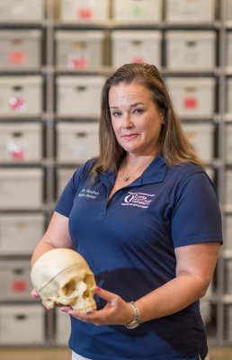

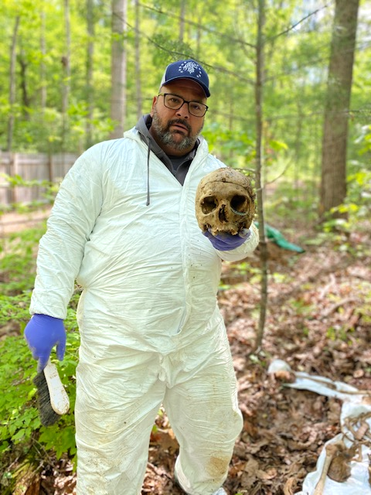

Injury & Death Investigations (Body Search Excavation and Recovery)
Dr. Freddy Ponce, PhD.
Miami Homicide(ret)/ CITGROUP

Emma O. Lew, M.D. Chief Medical Examiner Miami-Dade County (Ret.)
Dr. Heather Walsh-Haney, PhD.
Anthropologist
Florida Gulf Coast University

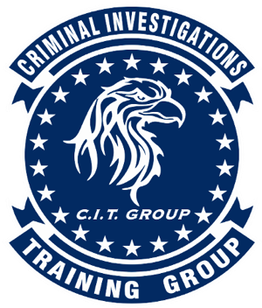
  - Criminal Investigations Training Group
  - CITGROUP
  - Injury and Death Investigations (Body Farm)

The one-week Injury & Death Investigations (Body Farm) course is directed by Criminal Investigations Training Group, which is dedicated to bringing the latest in training to law enforcement investigators, headed by former Miami Police Homicide Detective Dr. Freddy Ponce, PhD. The team in this course is comprised by top notch instructors and professors in their field; former Chief Medical Examiner, Dr. Emma O. Lew at Miami-Dade County Medical Examiner’s Office and Dr. Heather-Walsh Haney, PhD. Anthropologist/ Florida Gulf Coast University director of Forensic Sciences and Body Farm Facility.
  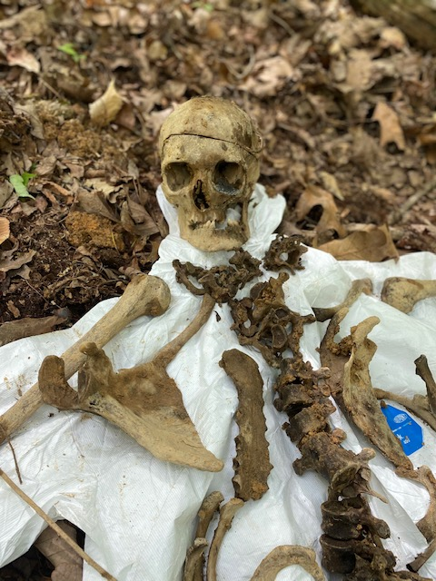
  Take your teams investigations to the next level and obtain the knowledge to closing cases!! 
  Crime Scene Identification
Injury and Death Investigations (BODY FARM)
DATE: February 16-20, 2026
Rate: $950.00 PP. Register and Pay online
Host Location: Cape Coral Police Department Training Center
1100 Cultural Park Blvd, Cape Coral Fl. 33990 Tel. 239-242-3348
Law enforcement and Crime Scene Investigators Only!
Contact: Dr. Freddy Ponce, Ph.D. Tel. 786-546-2467 citgroup25@gmail.com
www.CriminalInvestigationsTrainingGroup.com Register here!!!! Limited Seats left!
Contact@FreddyPonce.com

